**Activity – Life in the Soil**

***Mycorrhizae and Plants***

View this [video](https://youtu.be/lZVniNFTWh4) about mycorrhizae and the environment and answer the questions.

1. How do mycorrhizae operate?

**Hyphal networks bind to the root system and grow outward, expanding the amount of soil accessible to the plant. These mycorrhizae essentially trade water and soil nutrients with the plant in exchange for sugars from photosynthesis. Mycorrhizae can grow faster than plant roots can, and have much higher surface area, so they are effectively a big extension of the root system.**

1. What are the benefits of mycorrhiza?

**Plants with mycorrhizae improve plant nutrition and growth speed. Mycorrhizal plants can also tolerate stress better than plants without mycorrhizae. Underground networks of mycorrhizae can connect plants together, and provide support for young seedlings without developed root systems. Mycorrhizae can also improve soil aggregation.**

View this [video](https://www.youtube.com/watch?v=QYmrOrTM-FA) about mycorrhizae and how it works and answer the questions.

1. How do plants recognize their mycorrhizae counterparts?

**Normally, the plant’s immune system will kill hyphae. However, some fungi have adapted to emit chemical signals that block this immune response while they initiate their symbiosis.**

1. Describe the difference between endomycorrhizae and ectomycorrhizae.

**Ectomycorrhizae grow around the root tips of plants or around the plant cell, while endomycorrhizae extend hyphae into the root cells themselves. Ectomycorrhizae tend to form heavily folded structures, while endomycorrhizae may build a tree-like structure (arbuscular) within a plant cell.**

1. What is the most common mycorrhizal type?

**Arbuscular mycorrhizae (ectomycorrhizae) are the most common type. These are the mycorrhizae that build a tree-like structure within a plant cell with high surface area for resource exchange.**

1. When do ectomycorrhizal fungi developed and on what types of plants?

**Mycorrhizal fungi inhabit temperate and cold forests with lots of plant litter on the ground. They proliferated by solving the issue of nutrient availability in these areas.**

1. On what plants and ecosystems do ericoid mycorrhizal fungi inhabit?

**Ericoid mycorrhizae inhabit nutrient-poor habitats like bogs and heat lands, and grow with the Ericales order of plants.**

***The Basics behind Rhizobia***

View this [video](https://youtu.be/qqt9bp-zpeM) about Rhizobia and answer these questions.

1. How do nodules develops?  
   **Soybean seedlings emit a chemical signal that alerts Rhizobia in the soil to their presence. The Rhizobia emit their own chemical messages, which cause the plant to grow root hairs towards the Rhizobia. The Rhizobia then move into the plant cortex and form a symbiotic relationship, growing into a nodule.**
2. What is the benefit to the plant and to the bacteria?  
   **The plant benefits by having the bacteria fix atmospheric nitrogen into ammonia, giving the plant a source of nitrogen. The bacteria benefit by having a habitat formed for them to live in, as well as food from the plant.**

***Nitrogen Cycle***

Directions: Using the word bank, match the numbers with the letters. Hint: the purple boxes are processes such as mineralization, denitrification, etc.

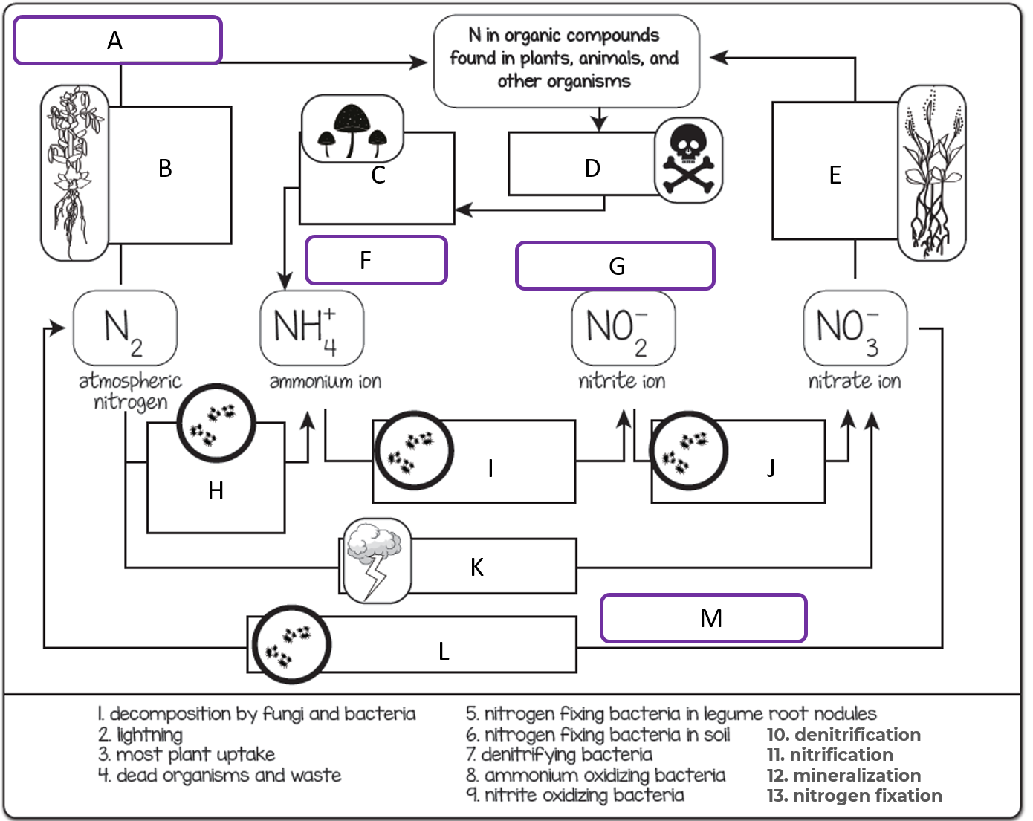

|  |  |  |  |
| --- | --- | --- | --- |
| Description | Letter | Description | Letter |
| Decomposition by fungi and bacteria | C | Most plant uptake | E |
| Lightning | K | Denitrifying bacteria | L |
| Denitrification | M | Nitrification | G |
| Dead organisms and waste | D | Ammonium oxidizing bacteria | I |
| Mineralization | F | Nitrogen fixation | A |
| Nitrogen fixing bacteria in soil | H | Nitrite oxidizing bacteria | J |
| Nitrogen fixing bacteria in legume root nodules | B |  |  |

1. If populations of free-living bacteria in the soil make nitrogen from the air available to organisms and that nitrogen is eventually absorbed and incorporated into plants, what is the most likely sequence of nitrogen changes in the soil and then in the plants?
2. If bacteria break down organic matter from debris and the nitrogen is converted into nitrates for plants to absorb, what is the most likely sequence of nitrogen changes?